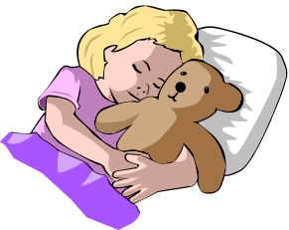
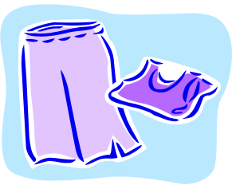
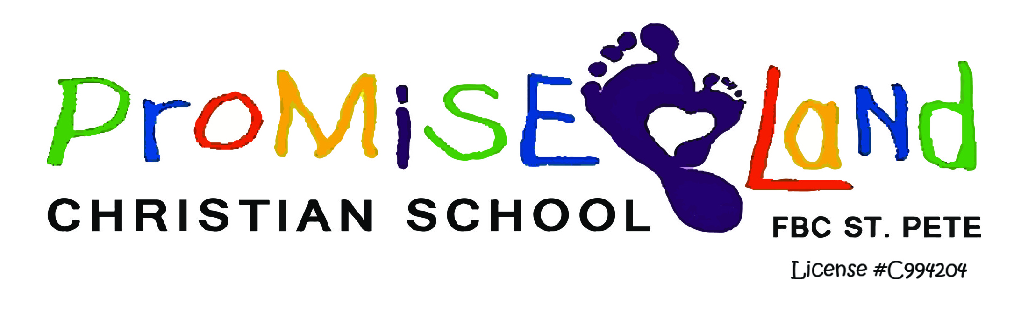

Each Child Needs…….

For Your Child’s Cubby
Shoebox size container (5”H x 12”L x 7”W-will fit in the cubby) with a lid that includes:
- 3 outfits (be aware of changing weather)
- 3 pairs of underwear (also stock cubby with pull-ups & wipes if your child is still training)
- 3 pairs of socks
- 1 pair of extra shoes

Please note:
- These clothes should be suitable for playing on the playground and art projects. Please DO NOT send your child in their nice, expensive clothing.
- Always send your child in CLOSED-TOE shoes.

For Naptime:
- A small blanket (please no pillows, comforters or sleeping bags)
- A soft toy (optional)

LABEL EVERYTHING!!!!!!!!!!

