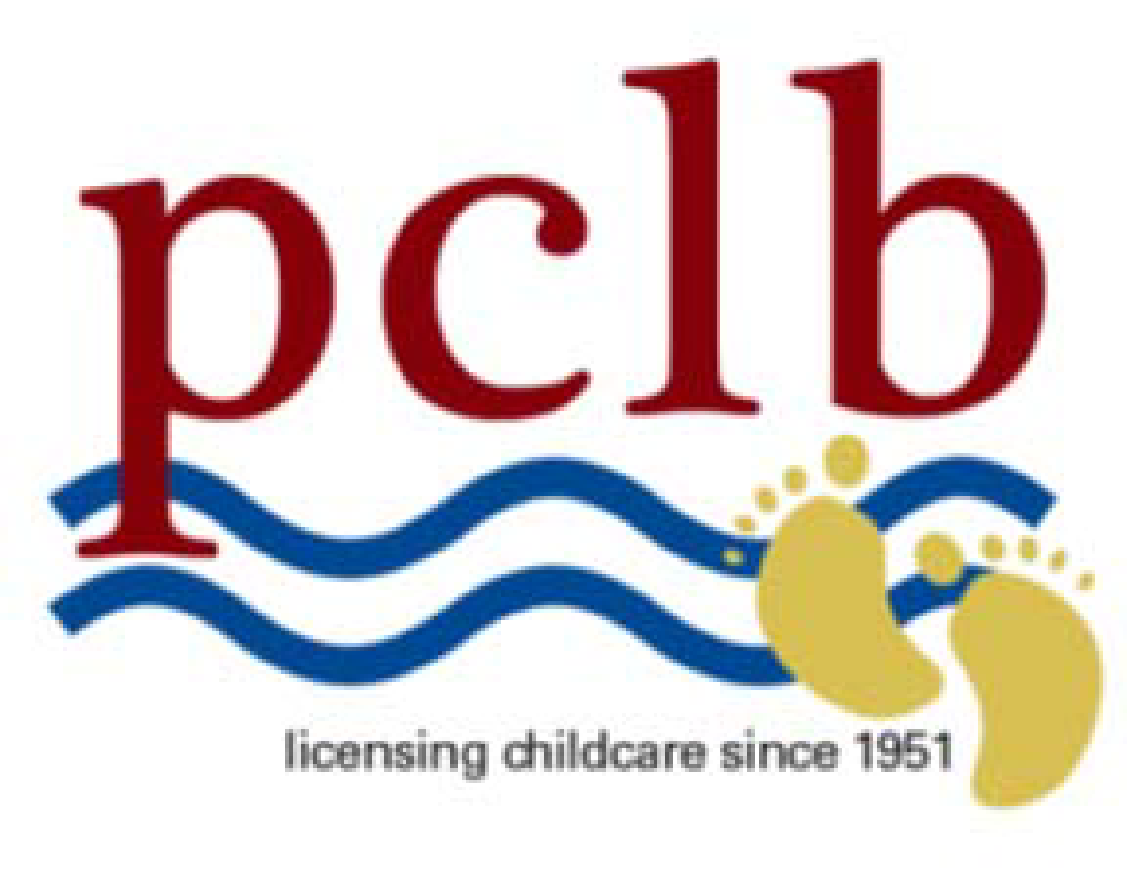

Food Experience Permission Form

I give permission for my child _________________________________ to participate in
food related activities.

Please check one of the following:

___________My child DOES NOT have a food allergy or dietary restriction.

___________My child DOES have a food allergy or dietary restriction. He or she may
participate, but may not eat or handle the following items (please list below)

___________My child DOES have a food allergy or dietary restriction. He or she may
not participate in activities.

_______________________________ ___________________________
Parent Signature Date

C- 1050 Sample Form PCLB 12/13

